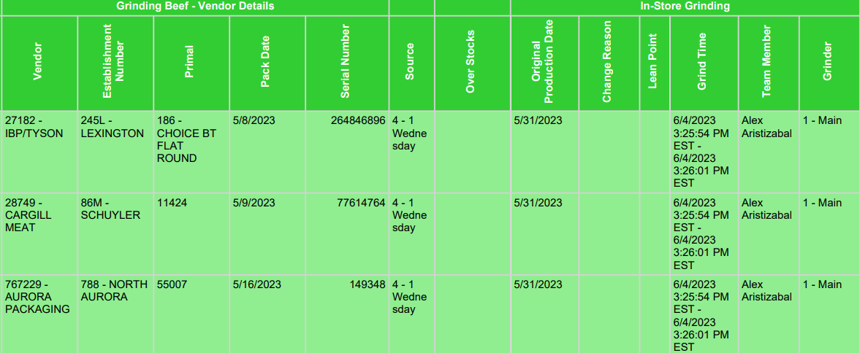

THIS IS AN EXAMPLE OF WHY I NEED TO ADD THIS FUNCTION. TO CLOSE LUG OUT WITHOUT DOCUMENTING IT. 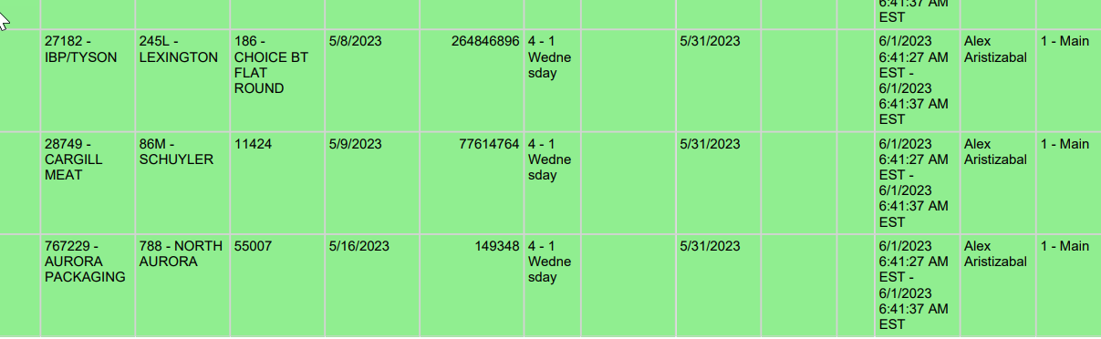

THIS IS WHEN THE ENTIRE LUG WAS USED BUIT NEVER CLOSED OUT UNTIL FRIDAY 6/4/23

5/31/23 IS A WEDNESDAY BUT A GRIND WAS PEFORMED ON SUNDAY 6/4/23 BEACAUSE IT WAS NEVER CLOSED OUT BY CHOOSING THE ENTIRE LUG FOR THAT WEDNESDAY. SO THEREFORE FALSIFYING DOCUMENTS BECAUSE THAT IS CURRENTLY THE OPTION. SO I NEED A WAY OF REMOVING THE LUG THAT WAS FORGOTTEN CAUSED BY (HUMAN ERROR). OUR POLICY IS TO HOLD TRIM NO LONGER THAN 48HRS. SO ACCORDING TO THE USDA THIS REPORT IS FALSE.