Idea list

1.

In the event batch you can no see what you selected to do.

Clear and reload

In the screen shot was it a reload or was it just a clear.

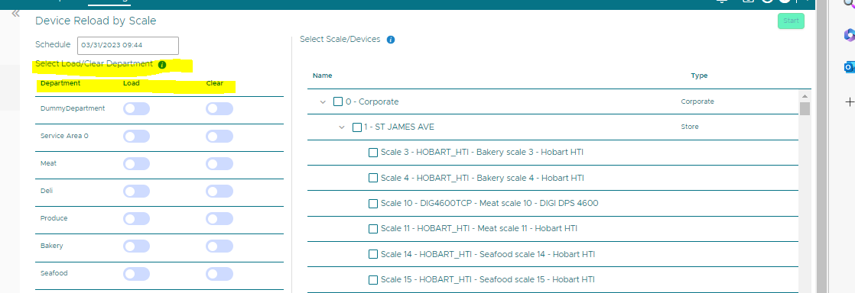

Is there some way to say Status Clear complete or Reload Complete or Clear & Reload complete.

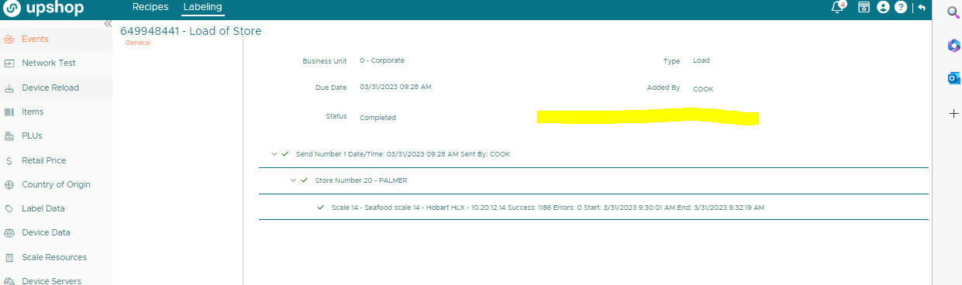

2.

In the organization / Units

You have a Search field that works great.

You type in a store number it pops right up

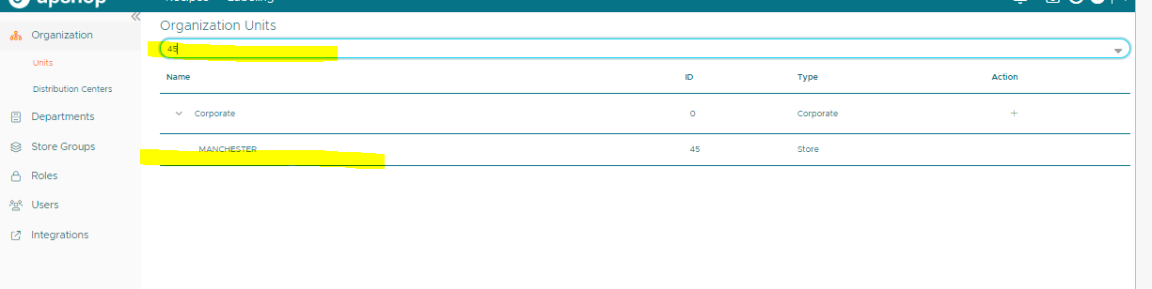

It would be really helpfully to have that here too.

To be able to type in the store number. This is so much faster then using the find option.

