Looking for prompt message with the same type of alert as “finalize this grind” only when selecting "YES" prompt with "Are you sure you want to use the entire lug". See below  
  
Selecting “YES”  
  
  
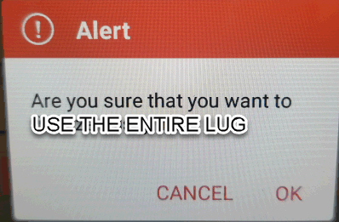  
  
Some of our users accidentally select yes while they still have trim from that day which you know closes out the day. I think with a prompt at that point might make them focus on the proper procedure.